Hw 03 Due 02/26/14

Page 82: # 6, 8, 30, 32.
If interpretations are requested, they must be made in the context of each question. In addition to samples about interpretations in book, examples 5 and 6 from class notes (lesson 2.4) also include samples of interpretations.

Page 86: # 10, 18, 22.
In Question #10, notice that you have to compute “successive rates of change for the function.”
In Question #18, make sure you relate stories a, b, c to tables E, F, G, and to graphs I, II, III.

Page 82

6). 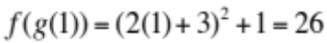
8). 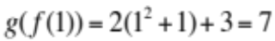

30).

a).
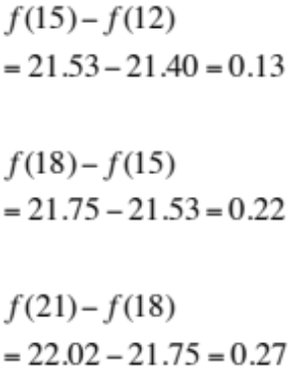
The cost for producing 10kg of a chemical is $102,000
b).

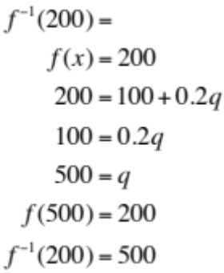
$200,000.00 will produce 500kgs of a chemical.
c).
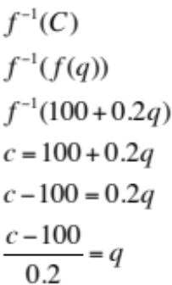
Amount of kilograms produced given a certain cost.

32).

a).
G(11) Represents the GDP in billions of dollars in the year 2001.
b). G-1(X) Represents the number of years since 1990, given the DGP is X Billion of dollars.

Page 86

10).
The graph is increasing and concave up.

18).
a). E
b). G
c). F

Page 88

22).
a).
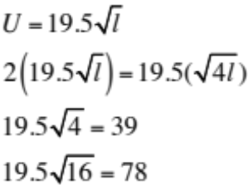

The salmon a has length 4. Salmon b has length 16.
The swimming speed of salmon b is 2a.

b).

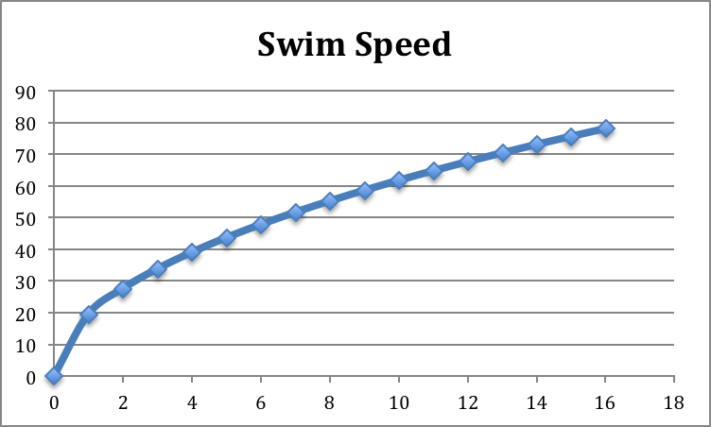

The graph is increasing and concave down.

c). Yes, because the graph is increasing.

d). The difference in speed between the two smaller fish is greater than the difference in speed between the two larger fish.
